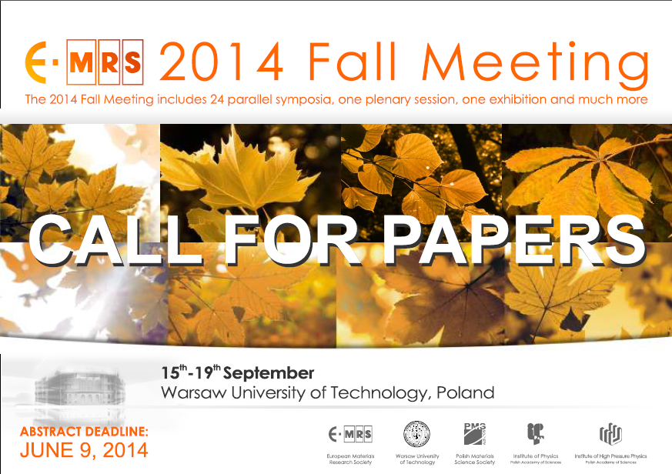
Full information about the scientific programme, abstract submission, registration and accommodation can be found through the link : http://www.emrs-strasbourg.com

Symposium M :
“Functional textiles– from research and development to innovations
and industrial uptake”
Sections:
- Functional textiles (in cooperation with 2BFUNTEX)
- Flame retardant textiles (in cooperation with COST MP1105, 15 reimbursements)
- Electrospinning (in cooperation with COST MP1206, 13 reimbursements)

Proposed time schedule: Tuesday morning 16th till Thursday noon 18th September 2014
(time of each section will be announced later and will depend on the number of participants in the section)

Selected papers will be published in the Autex Research Journal (http://www.autexrj.com).

Abstract submission deadline : Monday 9th June 2014
Abstracts need to be submitted online : see following link

Registration fees :
Early registration (till 31st July 2014) : 430 EUR regular and 280 EUR for students
Late registration : 480 EUR regular and 330 EUR for students
Note : a fee reduction for 2BFUNTEX, COST and ENMat members is under negotiation and will depend on the number of abstracts received.
More information : Prof. Rimvydas Milašius (rimvydas.milasius@ktu.lt)
The symposium M will be co-organized by the Coordination Action 2BFUNTEX, COST Action MP1105 FLARETEX and COST Action MP1206, and the European Network of Materials Research Centres ENMat.



